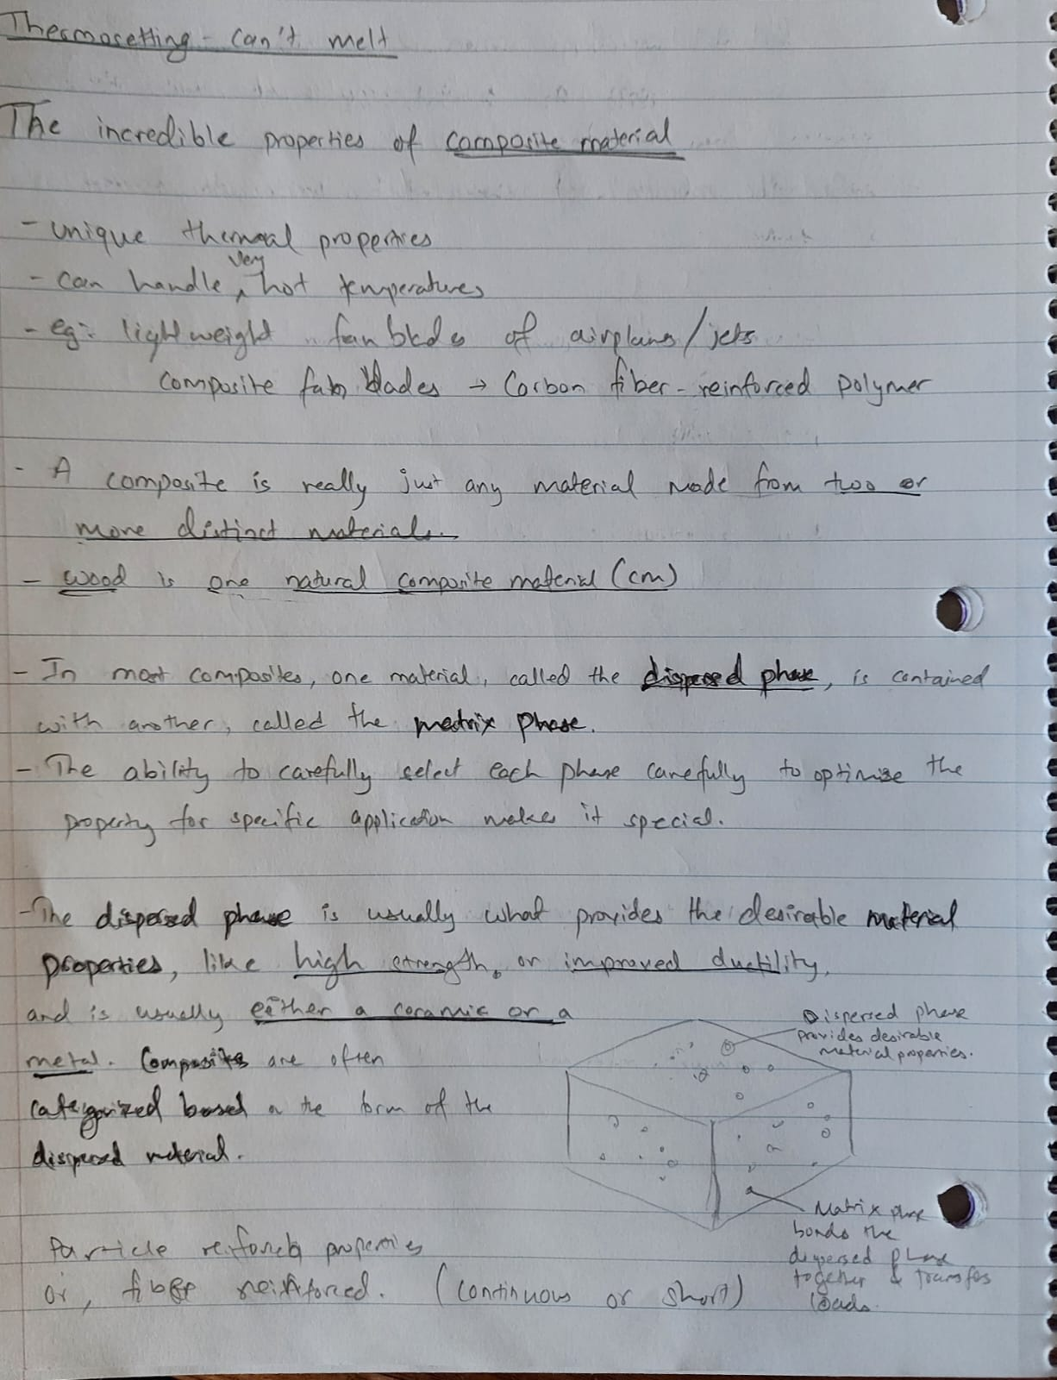

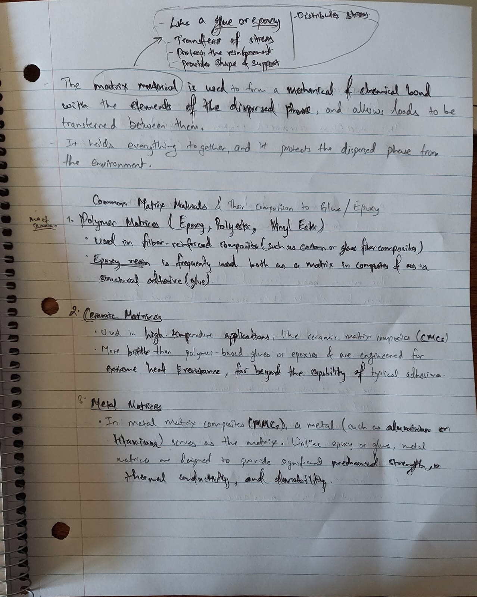

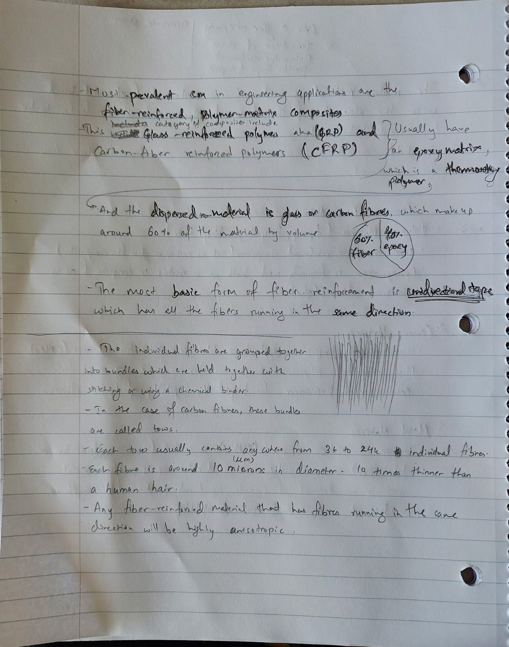

* Any fiber-reinforced material that has fibers all running in the same direction will be highly anisotropic. Its material properties will be different in different directions.
* If you apply a load along the axis of the fibers, the material will be much stronger and stiffer than if you apply it perpendicular to the axis, because the load is taken by the stronger and stiffer fibers instead of by the matrix.
* 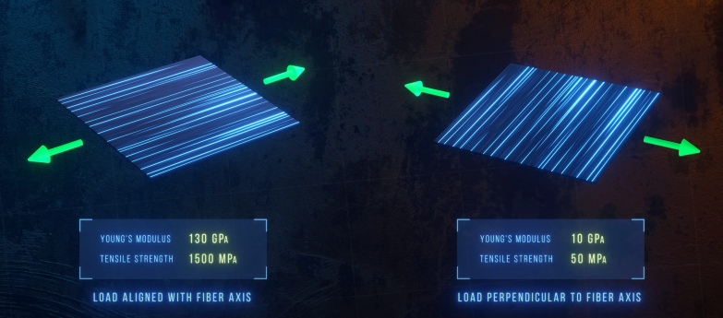
* Reinforcement in the axial or helical fibers
* 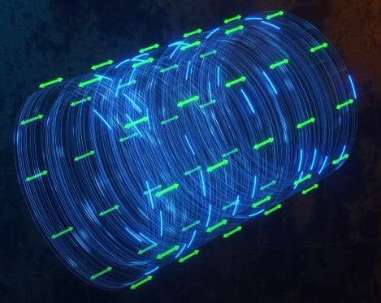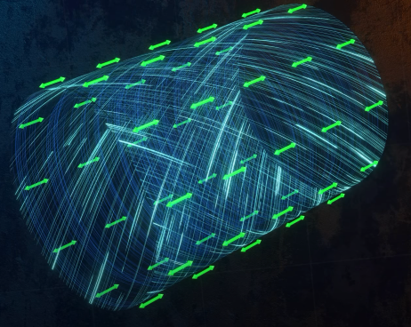
* 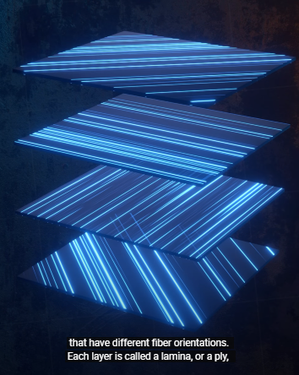
* 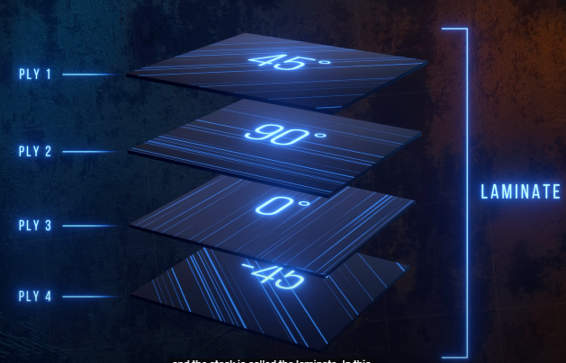
* In the ply, 0 degree layer provides strength and stiffness in the axial direction
* 90 degree in the transverse direction
* 45 in the sher direction.
* If all stacked together, will be quasi-isotropic laminate.
* 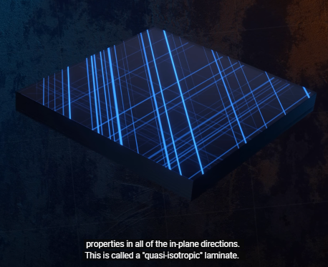
* Fibers can also be arranged in the weave patterns, which have fibers running in two different directions.
* 
 
 